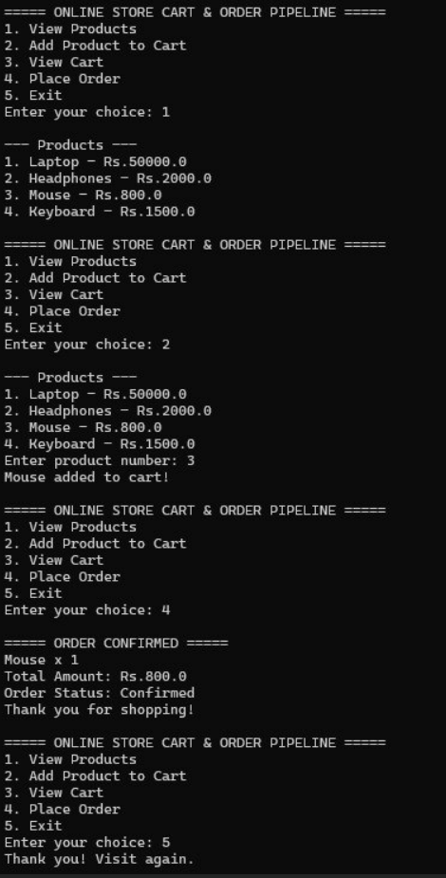

CODE
import java.util.Scanner;
public class OnlineStore {
public static void main(String[] args) {

Scanner sc = new Scanner(System.in);

String[] products = {"Laptop", "Headphones", "Mouse", "Keyboard"};
double[] prices = {50000, 2000, 800, 1500};

int[] cart = new int[4];

int choice;

do {
System.out.println("\n===== ONLINE STORE CART & ORDER PIPELINE =====");
System.out.println("1. View Products");
System.out.println("2. Add Product to Cart");
System.out.println("3. View Cart");
System.out.println("4. Place Order");
System.out.println("5. Exit");

System.out.print("Enter your choice: ");
choice = sc.nextInt();

switch (choice) {

case 1:
System.out.println("\n--- Products ---");

for (int i = 0; i < products.length; i++) {
System.out.println((i + 1) + ". " + products[i]
+ " - Rs." + prices[i]);
}
break;

case 2:
System.out.println("\n--- Products ---");

for (int i = 0; i < products.length; i++) {
System.out.println((i + 1) + ". " + products[i]
+ " - Rs." + prices[i]);
}

System.out.print("Enter product number: ");
int product = sc.nextInt();

if (product >= 1 && product <= products.length) {
cart[product - 1]++;
System.out.println(products[product - 1]
+ " added to cart!");
} else {
System.out.println("Invalid product number.");
}
break;

case 3:
System.out.println("\n--- Your Cart ---");

double total = 0;

for (int i = 0; i < products.length; i++) {

if (cart[i] > 0) {
double itemTotal = cart[i] * prices[i];

System.out.println(products[i]
+ " x " + cart[i]
+ " = Rs." + itemTotal);

total += itemTotal;
}
}

System.out.println("Total: Rs." + total);
break;

case 4:
double orderTotal = 0;

for (int i = 0; i < products.length; i++) {
orderTotal += cart[i] * prices[i];
}

if (orderTotal == 0) {
System.out.println("Your cart is empty!");
} else {
System.out.println("\n===== ORDER CONFIRMED =====");

for (int i = 0; i < products.length; i++) {
if (cart[i] > 0) {
System.out.println(products[i]
+ " x " + cart[i]);
}
}

System.out.println("Total Amount: Rs." + orderTotal);
System.out.println("Order Status: Confirmed");
System.out.println("Thank you for shopping!");

// Empty the cart after ordering
for (int i = 0; i < cart.length; i++) {
cart[i] = 0;
}
}
break;

case 5:
System.out.println("Thank you! Visit again.");
break;

default:
System.out.println("Invalid choice.");
}

} while (choice != 5);

sc.close();
}
}
rder Pipeline project aims to create a simple Java-based system for managing products, shopping carts, and orders. It demonstrates how Java concepts can be used to model a real-world online shopping process efficiently and systematically.

